The most socioeconomically disadvantaged groups are structurally under-served by urban infrastructure as compared to least disadvantaged groups.
https://journals.sagepub.com/doi/10.1177/23998083221131044

Poor and minority populations often live in socioeconomically disadvantaged neighborhoods, and neighborhood context directly affects access to food, safety, education, health behaviors, and stress levels.
Living in a disadvantaged neighborhood has been linked to higher rates of diabetes, cardiovascular disease, and other diseases; increased utilization of health services; and earlier death. ^{1–5} Moreover, neighborhood disadvantage may influence health independently of a person’s socioeconomic status: studies have suggested that poor people who live in wealthier neighborhoods may have better health outcomes than poor people who live in extremely disadvantaged neighborhoods.^{2,5}
- https://pmc.ncbi.nlm.nih.gov/articles/PMC6051533/
Concentrated disadvantage is one of several structural indices used to capture the socioeconomic conditions of neighborhoods; it is often examined alongside related measures such as concentrated affluence, residential stability, and immigrant concentration. Researchers also employ broader inequality metrics—most notably the Index of Concentration at the Extremes, which reflects the spatial separation of affluence and deprivation.[5][6] Together, these indices describe complementary dimensions of neighborhood structure and context, enabling a more comprehensive understanding of how place-based conditions shape social, economic, and health outcomes.
Residents of neighborhoods characterized by concentrated disadvantage experience worse physical and mental health across the life course, including higher rates of chronic disease, infant mortality, and physiological stress.[7][8] These health disparities reflect both material hardship and the cumulative biological strain associated with living in persistently deprived environments.
Long-term studies show that children raised in neighborhoods with concentrated disadvantage experience reduced upward mobility and poorer adult outcomes, including lower earnings and greater criminal justice involvement.[19][20] These effects accumulate across generations, reinforcing persistent spatial inequality.[21]
https://en.wikipedia.org/wiki/Concentrated_disadvantage

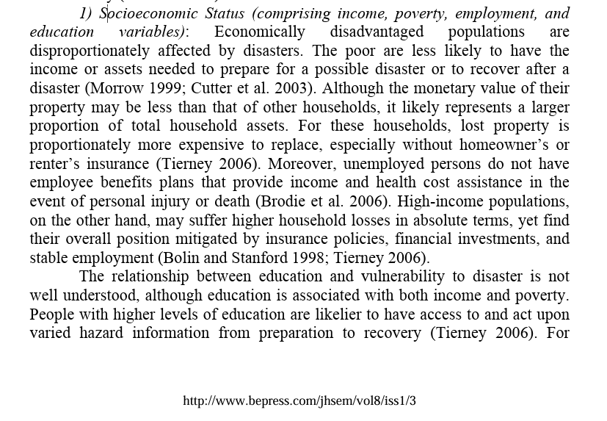
'In Kanaleneiland wonen niet alleen arme, miezerige, zielige mensen'
https://nos.nl/artikel/2321495-in-kanaleneiland-wonen-niet-alleen-arme-miezerige-zielige-mensen

Mental health and income mediate built environment impacts more strongly than age.
For physical activity, social and recreational activities, built environment characteristics accounted for about 60 percent of the total relative importance, suggesting that built environment factors have a significant impact in predicting activity among older people and are more important than the individual socio-demographic characteristics of older adults, which supports previous research
Among socio-demographic attributes, the top three factors influencing physical activity were mental health status (6.15 %), income (5.62 %) and physical health status (5.20 %), while the top three variables have the greatest impact on social and recreational activities were income (6.93 %), marriage (5.45 %) and mental health (4.24 %). The results show that income has the greatest influence on both types of activities among the elderly. Marriage and mental health had a greater impact on social and recreational activities, as older seniors with a partner were more likely to be involved in social and recreational activities. Physical and mental health was more important than marital status for physical activity, suggesting that physical activity responded more significantly to health status characteristics of older adults. This is consistent with previous research (Sawińska, 2023) in that older adults typically establish new habits as their health status changes, which has the potential to alter the level of physical activity hours.
In general, the observation indicate that elderly individuals tend to engage more in social activities than physical activities. Social activities often require less physical exertion, making them more accessible for older adults, particularly those with mobility limitations or chronic health conditions. Activities such as chatting with friends, participating in community events, or attending cultural gatherings provide meaningful engagement without the physical strain associated with exercise or sports.
https://www.sciencedirect.com/science/article/pii/S0143622826000147?via%3Dihub
The results show that citizens' perceptions of safety and place attachment are positively associated with civic engagement, indicating that feeling secure and emotionally connected to the city supports participation in local decision-making. Health and well-being are significantly and positively influenced by perceptions of safety, recreation, and primary services, demonstrating that everyday conditions—protection, access to services, and opportunities for leisure—are central to perceived urban sustainability. At the same time, lower levels of health and well-being are associated with higher levels of civic engagement, suggesting that dissatisfaction with urban conditions can motivate political participation and demands for accountability.
https://www.sciencedirect.com/science/article/pii/S0264275126000740?pes=vor&utm_source=scopus&getft_integrator=scopus
Krebs Cycle of Design for Vulnerables
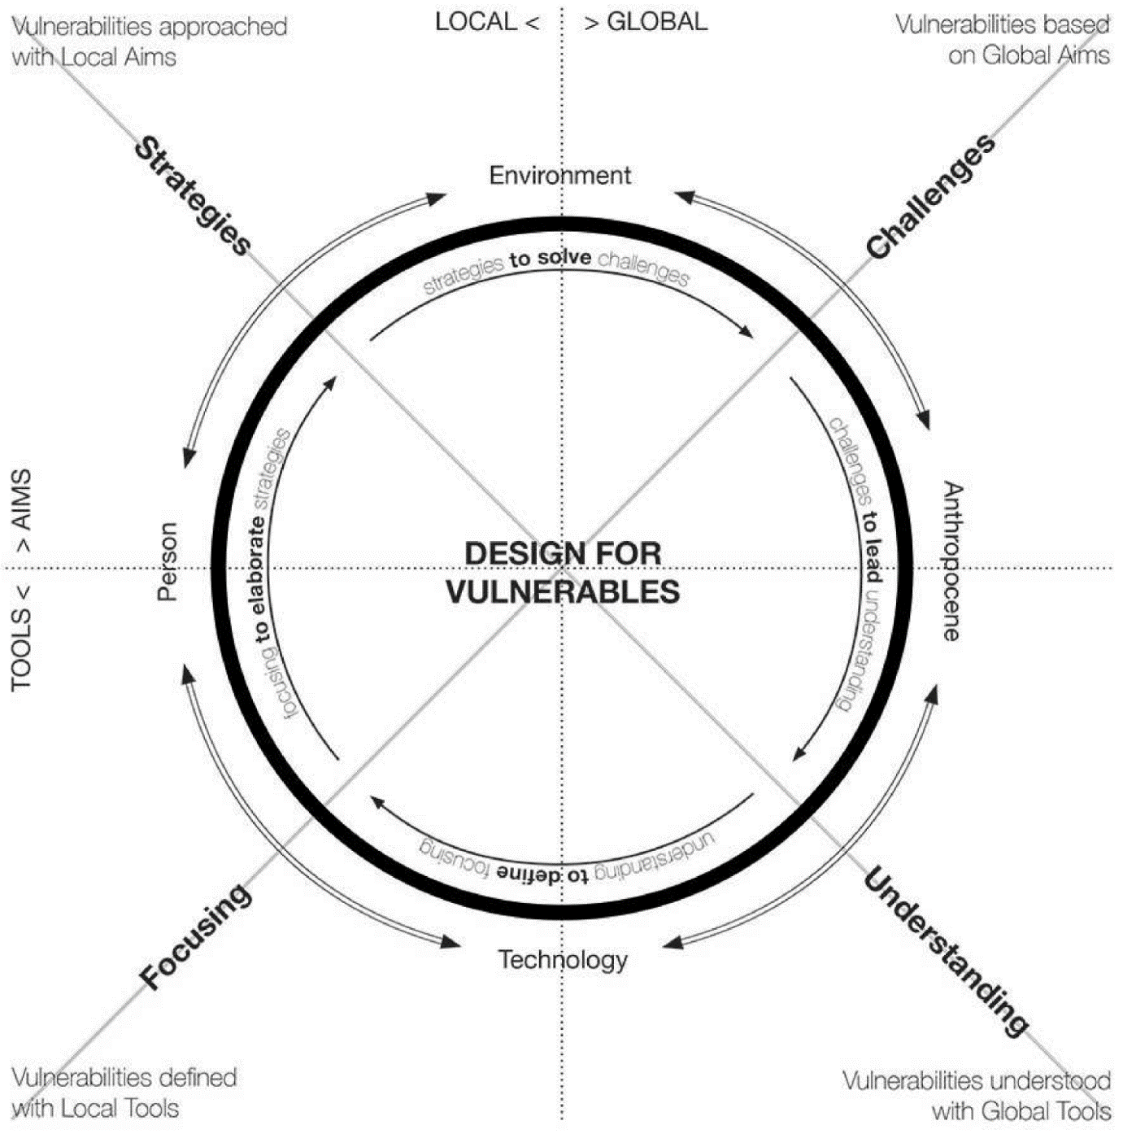
https://www.mdpi.com/2075-5309/12/11/1789#Discussion_Generated_by_the_Comparison

Book: https://link.springer.com/book/10.1007/978-3-030-96866-3

Vision support / design against concentrated disadvantages (by ChatGPT)

Dudley Street Neighborhood Initiative — Boston, USA
- Residents reclaimed vacant land, used eminent domain to create affordable housing, parks, and community spaces.
- Strong resident involvement contributed to reduced crime, higher property values, and stronger community cohesion.

Twin Parks Community Initiative — Minneapolis, USA
- Transformed vacant lots into affordable homes and community spaces.
- Combined housing development with job training and economic support.

Sustainable South Bronx — New York, USA
- Environmental justice-oriented regeneration that created green infrastructure and green-job training.
- Blends ecological improvements with economic opportunity and health benefits.
https://homesight.org/case-studies-successful-community-development-initiatives/

German “Socially Integrative City” Program
- Publicly funded, area-based regeneration that combines physical upgrades with social networks, empowerment, training, and services.
- Focused on inclusion rather than just physical change.
https://www.sciencedirect.com/science/article/pii/S2095263521001011

Nordic Social Inclusion Projects (e.g., Bergsjön)
- Examples where cultural centers and inclusive planning were used to strengthen community connection and reduce segregation.
- Highlights importance of local associations and tailored interventions.
https://pub.nordregio.org/r-2025-7-beyond-segregation-nordic-approaches-to-socially-inclusive-cities/7-discussion.html

URBACT Good Practices for Inclusive Cities (Europe)
- Bundle complementary projects that integrate education, health, job access, and community engagement in areas such as Satu Mare (Romania) and Reggio Emilia (Italy).
- Participatory approaches and multi-sectoral collaborations are key.
https://urbact.eu/whats-new/stories/nine-urbact-good-practices-inclusive-cities

Urban Commons & Placemaking
- Community-led improvement of neglected parks can foster ownership, participation, and healthier urban ecology even in disadvantaged zones.
https://www.sciencedirect.com/science/article/pii/S1353829222000387

Greening Vacant Lots (Research Influence)
- Simple greening and remediation of vacant land has documented reductions in crime and improved community wellbeing, showing the value of small-cost, place-based fixes.

Research and Policy Frameworks (Supporting Practice)
These include documented experiences in spatial justice, inclusive planning, and weak market cities, which provide broader context and policy learning:
- Urban regeneration case research in Józsefváros, Budapest shows how equity and spatial justice can reframe disadvantaged area redevelopments.
https://www.researchgate.net/publication/382369360_Spatial_Justice_in_Urban_Regeneration_-_Case_Study_Budapest_Jozsefvaros
- European/US comparisons in weak-market cities (LSE research) highlight shared challenges and recovery catalysts.
https://sticerd.lse.ac.uk/case/_new/research/weak-market-cities/

Global Land-Policy & Equity Interventions
From the Equitable Cities Initiative, international examples include:
- Opportunity Clusters Framework in Minneapolis–St. Paul — targeting racial disparities in income and opportunity.
- Moderately Priced Dwelling Units (MPDU) in Montgomery County — a long-standing inclusive housing strategy.
- São Paulo value-capture land policy — using zoning to reinvest value into equitable outcomes.
- Affordable home ownership efforts in Addis Ababa — integrating services with housing.
https://www.lincolninst.edu/es/case-studies/equitable-cities-initiative/

